|  |
| --- |
| Reading: *Frederick* by Leo Lionni  Lisa Cole, Library Practicum Student  Julie Tempelmeyer, Library Media Specialists  Suzonne Classen - Second Grade Teacher  Burlington Elementary School, Burlington, KS |

**Grade Level:** 2nd Grade (Two second grade classes come to the library at the same time, so there will be 30 students participating in this activity.)

**Lesson Overview:** The lessonwill begin by using a ‘web’ graphic organizer to see what we know about mice. A few facts and pictures from a nonfiction book will be shared. Students will predict what will happen in the fiction story of Frederick. Next, students will demonstrate understanding of the literacy term “cause and effect” by answering questions of “what happens next” after listening to the story of *Frederick.* Students will then do a character analysis of Frederick by answering questions about Frederick. Students will write a minimum of one sentence to describe how they feel about Frederick and why they feel this way, and then draw a picture of Frederick. These pages will be made into books for the classrooms.

**Time Frame:** One class period of 45 minutes.

**Content Area Standards for Reading 2nd Grade:**

Standard 1: The student reads and comprehends text across the curriculum.

Benchmark 4: The student comprehends a variety of texts (*narrative*, *expository*, *technical*, and *persuasive*).

Standard 2: The student reads and responds to a variety of text.

Benchmark 1: The student uses literary concepts to interpret and respond to text.

**Kansas Curricular Standards for Library Media:**

Standard 2: The student who is information literate evaluates information critically and competently.

Benchmark 1: Determines accuracy, relevance, and comprehensiveness.

Benchmark 2: Distinguishes among fact, point of view, and opinion.

Standard 3: The student who is information literate uses information accurately and creatively.

Benchmark 1: Organizes information for practical applications.

Benchmark 2: Integrates new information into one’s own knowledge.

Standard 5: The student who is an independent learner is information literate and appreciates literature and other creative expressions of information.

Benchmark 1: Is a competent and self-motivated reader.

**Collaboration with the Teacher:**

According to the teacher and the LMS, this unit of study will help students with comprehension skills, and help prepare students for reading tests. Since I will only see the students once while I am doing my practicum, this plan had to be for one day. We also do not have access to computers in the library and cannot use the computer lab, so we needed to stick to non-technology standards. The LMS, who is also the chair to the reading team at the school, and the classroom teachers have certain skills they know the students need to work on, and these are a couple of the skills that have been chosen. The classroom teacher said that she has assessed these skills through PALS, running records, STAR, and MAP tests. The classroom teacher felt the graphic organizer is always good to help students focus on the topic and then to incorporate “cause and effect” and “character analysis” from a story. The LMS and I decided on a good story in order to teach these skills. I gathered and prepared the materials and developed an assessment chart to assess behavior, participation, and product. The assessment chart was approved by the LMS and teacher.

**Cooperative Teaching Plan:**

**Library Media Practicum Student Will:**

* Lead a class discussion about mice to create a web graphic organizer
* Share facts and pictures of different kinds of mice
* Read *Frederick* by Leo Leonni
* Lead a discussion and then help complete a “cause and effect” paper about the book
* Lead a discussion on character analysis using Frederick from the book
* Help students construct their sentences and illustrations.
* Laminate and bind all pages together to create class book
* Evaluate student work with rubric.

**The Teacher Will:**

* For this lesson, the teachers will not be participating in the learning activities. They will send the children to the library and I will be responsible for the students. The teachers and the LMS approved these plans. The concepts that are being focused on in this lesson are also taught continuously in the classroom, and these concepts will reinforce reading comprehension.

**Resources:**

Lionni, Leo. Frederick. New York: Dragonfly Books.

Markle, Sandra. Outside and Inside Rats and Mice. New York: Atheneum Books for Young

Children.

**Materials:**

* Dry erase board
* Books
* Cause and Effect worksheet
* Frederick Character Analysis Sentence paper
* Chart Paper
* Crayons, glue, pencils
* Lesson Rubric

**Product or Culminating Activity:**

* Cause and Effect Worksheet
* Students will write at least one sentence describing how they fell about Frederick and then draw a picture of Frederick. These papers will be used to create a book for the classrooms.

**Adaptations and Extensions:**

I will be reading the questions to the students because many of the students are low readers. At least two students will be with a para-aide to assist with this activity. There are no second language learners in this school so bilingual support is not needed. Extensions activities will be to read more Leo Lionni books with the students that also include mice which are entitled *Matthew’s Dream* and *Tillie and the Wall.*

**Assessment Overview:**

This lesson will be assessed by the Library Practicum student and the LMS by using a rubric. (See attached) Classroom teachers will be made aware of the results.

**Assessment Results:**

Besides some behavior problems, the results of this lesson were amazing! Every single student except one, got every question correct on the Cause and Effect paper, and all but one different student was able to tell what they thought about Frederick and give a supporting sentence for their feeling. The one student that did not give a clear reason on the character analysis, wrote a sentence but it was not a good supporting sentence, but he did write a sentence. Basically all the students participated while creating the mouse graphic organizer and character analysis organizer. The few behavior problems were quickly squelched. All the students ended up getting 10 out of 10 because of how my rubric read. One para-aide needed to help the student stay focused and helped the student write a supporting sentence. The other para-aide that was in the library did not need to help her student.

Classroom books were made from the Character Analysis and the teachers thought they were great.

**Collaboration with the Teacher after the lesson-**

The classroom teacher was happy with the results of the lesson and feels that this was a good review for her students. She said that it is good for the students to have someone else teach the same topic, because the students get it in different situations. She said that many times her students will say excitedly, we did that is library. The teacher said that reading is an ongoing learning experience, so she is glad we reviewed these skills again so they are fresh in the students’ minds when she does diagnostic testing. It will be hard to tell if the lesson had a direct impact on test results, but repeating reading comprehensions skills over and over is very important. The teacher also enjoyed the character analysis books made from the student pages and felt it was good for students to see what other students wrote. The teachers and I both agreed that the standards were met in this lesson.

**My personal reflection on the lesson**-

Although this lesson probably needed to be a quick, one-class lesson, it could easily have been expanded into more learning and fun. Some suggestions would be to team up with the computer lab to research mice and fill in a KWL chart, role play cause and effect, or role play characters in the book to express how the characters might have felt about Frederick. With the time limit I was on of only having 45 minutes, and since my practicum days only allowed me to see this class once, I was limited with this lesson, but I can foresee lots of learning opportunities I could do with this lesson at another time.

**Rubric for Literacy Unit on *Frederick* by Leo Leonni – 2nd Grade**

Student Name___________________________________________

Total Points: ________

|  |  |  |  |
| --- | --- | --- | --- |
| **Activity** | **Great Job!**  **(2 pts)** | **Attempted**  **(1 pt)** | **Did not Complete (0 pt)** |
| Participated in discussions |  |  |  |
| Completed a cause and effect paper |  |  |  |
| Wrote at least one sentence describing how they feel about Frederick |  |  |  |
| Completed an illustration of Frederick |  |  |  |
| Stayed focused and cooperated during the lesson |  |  |  |

Name:_____________________________________



Frederick by Leo Leonni

(Cause and Effect – What happens next.)

1. Winter comes and it begins to snow.

The mice go to their hiding place.

The mice gather food for winter.

1. The mice eat all of their food.

They ask Frederick about his supplies.

They tell stories about silly cats.

3. Frederick talks about the colors of the plants.

The mice ask Frederick why he does not work.

The mice see the colors in their minds.

4. Frederick helps the mice think about the sun.

The mice gather some corn.

The mice feel warmer.

5. Frederick says a poem.

The mice clap.

The mice gather nuts.



Questions taken from The Mailbox- *Teacher’s Helper* Dec/Jan. 2004-5.

**Frederick!**

**I think Frederick is _________________________**

**because_____________________________________________________________________________________________________________________________________________________________ .**

**Draw a picture of Frederick!**

**Pictures of the Elementary Practicum lesson “Frederick” by Leo Lionni**

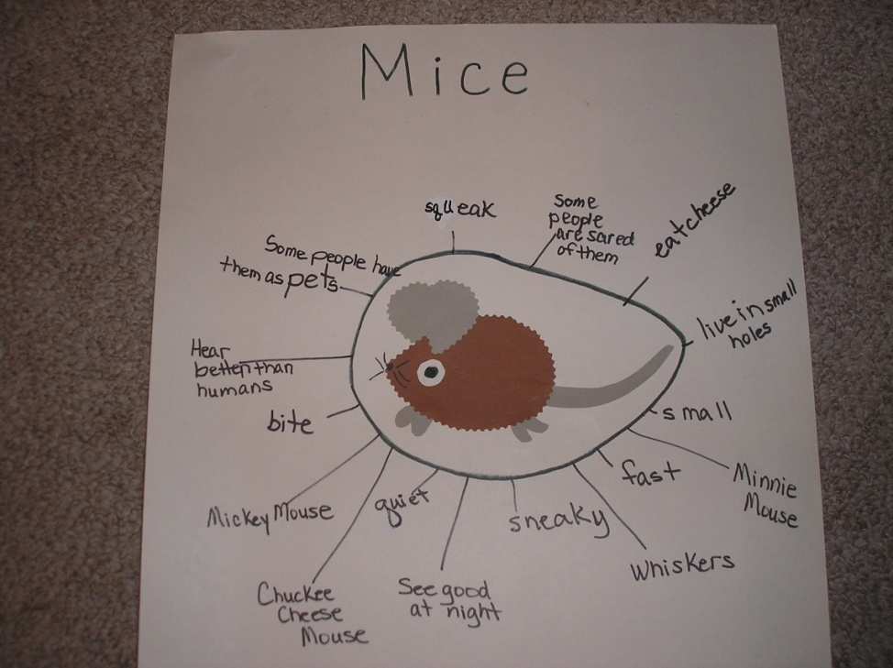

This is a picture of the graphic organizer that I did with the 2nd grade class

for my collaborative lesson.

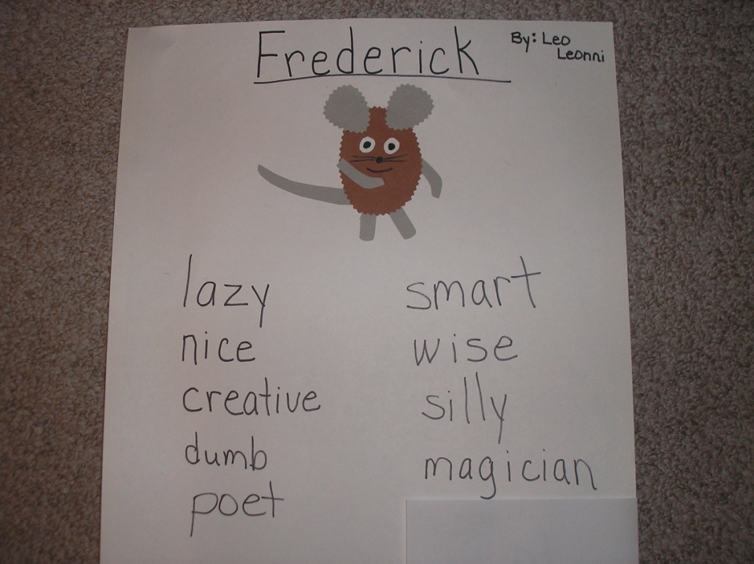

After reading the book we talked about the character of Frederick and brainstormed

descriptive words of what students felt about him. This lead into students doing their

own character analysis of Frederick.

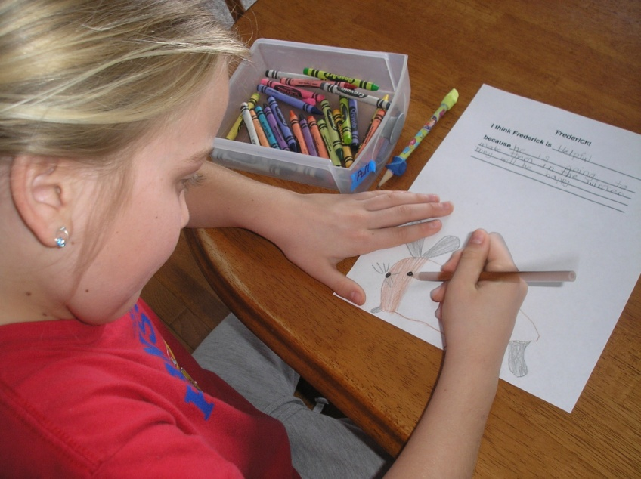

One of the students is finishing her character analysis of Frederick.

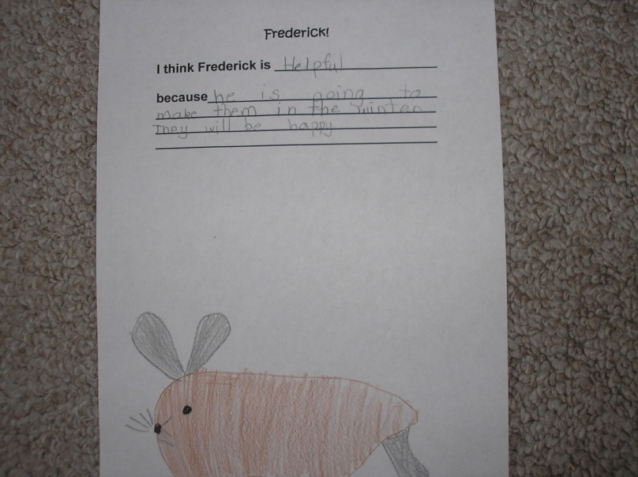

This student thought Frederick was helpful.

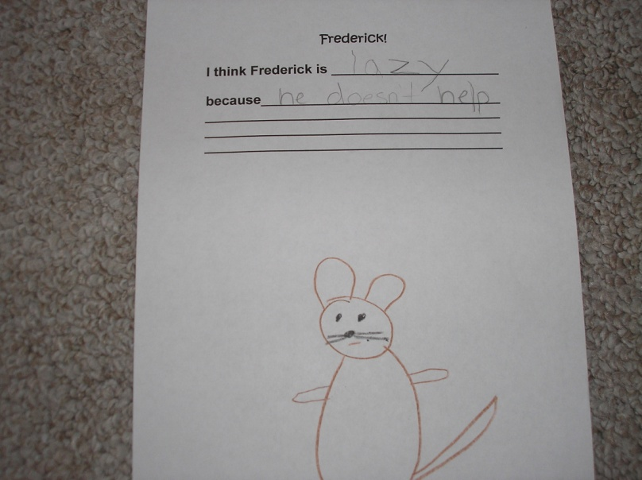

This student thought Frederick was lazy.

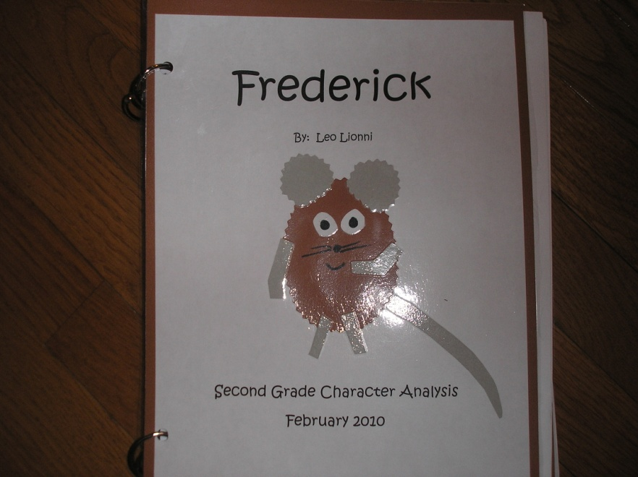

This is the book that was made for each class using the character analysis

of Frederick.